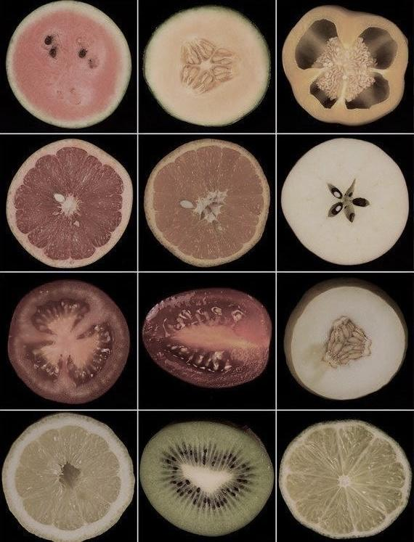
I do not speak on sex because sex has spoken for me since my Birth. Mom and Dad dreamt of a beautiful baby Boy; consumed by ex-Religious prayers and the yellow of Starry Night upon the walls. Cameron. I was to be Named. It feels dirty in my mouth, like the phallicity of everything spoon-fed beside the dining table. Turn on the television, then face the Wrong direction, Dad.
I will see le train de réfléchir qu’on ne peut pas arrêter.

- [We] are twenty years old. [We] are far too familiar with Sex and Entitlement: it is all that is taboo and it is all that [we] know.

- Born into a Body of Sex. Consummate.

- Hyper-vigilant of all actions due to Fear of Sex, therefore, [we] begin to Fear self.
  - “Falling Behind” in rotations of hips and drops of sweat: How many Bodies?
  - Baby Boy acts like a Boy because He is a Boy and He is Beautiful.
He teases [hits] you because He likes you
  - Baby Boy laughs at Baby Boys because they are not Man like Him
Pussy. Pussy. Bitch.

[I need not speak of the Feminine Form and how it is utilized in sMothering the masculine. Just look]

With Sex, [we] suffice some, but [we] are fucked to death by numbers of Bodies, high or low.
The Cost of lying cold, naked far beyond the Body, as [you] wait and listen. He comes back to the dark, breathes. Brushes [your] hair, passing ties of semen He graciously forgot. He is Generative, to purify with pleasure [you] do not femininely feel.

- There is a disconnect. Kor[ai] of Phrasikleia, say the Name of Maker. Inscribe.

Hook-up culture: Fuck me quick, then [we] can go on and forget (freedom).
Appear. Perform. Swipe. Disappear into the skin [you] believe [you] own.
Men do not always want Sex, nor do Women. We are more than Bodies of Sex. We are more than Sex. Return to relations Valued through Meaning formed by Self. Love can be found There.
